PROJECT REPORT

ON

**MONOSTABLE MULTIVIBRATOR**

Submitted for partial fulfillment of award of the degree of

**Bachelor of Technology**

In

**Electronics & Communication Engineering**

Submitted By

**HARSHIT UPADHYAY 1901920310065**

**YASH TOMAR 1901920310184**



Department of Electronics & Communication Engineering

**G. L. BAJAJ INSTITUTE OF TECHNOLOGY AND**

**MANAGEMENT, GREATER NOIDA**

**Session: 2021-22**

**ACKNOWLEDGEMENT**First and foremost we whole heartedly thank the Lord almighty for blessing us and guiding us throughout the project work. We render our heartfelt thanks to our teachers **Mr. MAYANK RAI**, for giving us opportunity to do this project. We also thank to our HOD sir **DR. SATYENDRA SHARMA** for giving kind constant to carry out the project. We also thank our staff members for helpings throughout this project. We also express my heartfelt thanks to my parents, friends one and all who helped us to carry our project in a successful manner.

**TABLE OF CONTENTS**

|  |  |
| --- | --- |
| **LIST OF FIGURES** | **PAGE NO** |
| **1.Introduction** | **1-2** |
| **2.Components Used** | **2-17** |
| **2.1 555 TIMER IC** | **2-5** |
| **2.2 RESISTOR** | **6-11** |
| 2.3 CAPACITORS | **12-13** |
| 2.4 GENERAL PURPOSE PCB | **14-16** |
| **2.5 BATTERY (12V)** | **17** |
| **3. CIRCUIT DIAGRAM** | **18** |
| **4. WORKING PRINCIPLE** | **19** |
| **5. OUTPUT WAVEFORM** | **20** |
| **6. SPECIFICATIONS** | **21** |
| **7. APPLICATIONS** | **21-22** |
| **8. COST OF EQUIPMENT** | **22** |
| **9. ADVANTAGE** | **23** |
| **10.FUTURE SCOPE** | **23** |
| **11.REFERENCE** | **24** |

**LIST OF FIGURES**

|  |  |  |
| --- | --- | --- |
| **FIGURE NO.** | **NAME OF FIGURES** | **PAGE NO.** |
| **1.** | **INTERNAL LAYOUT** | **5** |
| **2.** | **RESISTOR** | **10** |
| **3.** | **RESISTOR COLOR CODE** | **11** |
| **4.** | **PCB** | **15** |
| **5.** | **BATTERY 12V** | **17** |
| **6.** | **CIRCUIT DIAGRAM** | **18** |
| **7.** |  | **19** |
| **8.** | **OUTPUT WAVEFORM** | **20** |
| **9.** | **HIDDEN ACTIVE CELL PHONE DETECTOR** | **21** |
| **10.** | **TOUCH CONTROLLED LOAD SWITCH** | **22** |

**ABSTRACT**

A **monostable multivibrator**, also called a **one shot** or a **monoflop**, is a sequential logic electronic circuit that generates an output pulse. When triggered, a pulse of pre-defined duration is produced. The circuit then returns to its stable state and produces no more output until triggered again.

Monostable may be considered as a biased form of multivibrator where it is stable in one state until triggered, then unstable and will return spontaneously.

If repeated application of the input pulse maintains the circuit in the unstable state, it is called a *retriggerable* monostable. If further trigger pulses do not affect the period, the circuit is a *non-retriggerable* monostable.

1.**INTRODUCTION**

We’ve already seen one example of a monostable multivibrator in use: the pulse detector used within the circuitry of flip-flops, to enable the latch portion for a brief time when the clock input signal transitions from either low to high or high to low.

The pulse detector is classified as a monostable multivibrator because it has only one stable state. By stable, I mean a state of output where the device is able to latch or hold to forever, without external prodding.

A latch or flip-flop, being a bistable device, can hold in either the “set” or “reset” state for an indefinite period of time. Once its set or reset, it will continue to latch in that state unless prompted to change by an external input.

A monostable device, on the other hand, is only able to hold in one particular state indefinitely. Its other state can only be held momentarily when triggered by an external input.

A mechanical analogy of a monostable device would be a momentary contact pushbutton switch, which spring-returns to its normal (stable) position when pressure is removed from its button actuator.

Likewise, a standard wall (toggle) switch, such as the type used to turn lights on and off in a house, is a bistable device. It can latch in one of two modes: on or off.

All monostable multivibrators are timed devices. That is, their unstable output state will hold only for a certain minimum amount of time before returning to its stable state.

With semiconductor monostable circuits, this timing function is typically accomplished through the use of resistors and capacitors, making use of the exponential charging rates of RC circuits.

A comparator is often used to compare the voltage across the charging (or discharging) capacitor with a steady reference voltage, and the on/off output of the comparator used for a logic signal

Review:

* A *monostable* multivibrator has only one stable output state. The other output state can only be maintained temporarily.
* Monostable multivibrators, sometimes called *one-shots*, come in two basic varieties: *retriggerable* and *nonretriggerable*.
* One-shot circuits with very short time settings may be used to *debounce* the “dirty” signals created by mechanical switch contacts.

**2.COMPONENTS USED:**

**2.1 555 TIMER IC**

[**IC 555 timer**](http://www.engineersgarage.com/electronic-components/ne555-timer-ic-datasheet) is a well-known component in the electronic circles but what is not known to most of the people is the internal circuitry of the IC and the function of various pins present there in the IC. Let me tell you a **fact about why 555 timer is called so**, the timer got its name from the three 5 kilo-ohm resistor in series employed in the internal circuit of the IC.

IC 555 timer is a one of the most widely used IC in electronics and is used in various electronic circuits for its robust and stable properties. It works as square-wave form generator with duty cycle varying from 50% to 100%, Oscillator and can also provide time delay in circuits. The 555 timer got its name from the three 5k ohm resistor connected in a voltage-divider pattern which is shown in the figure below. A simplified diagram of the internal circuit is given below for better understanding as the full internal circuit consists of over more than 16 resistors, 20 transistors, 2 diodes, a flip-flop and many other circuit components.

The 555 timer comes as 8 pin DIP (Dual In-line Package) device. There is also a 556 dual version of 555 timer which consists of two complete 555 timers in 14 DIP and a 558 quadruple timer which is consisting of four 555 timer in one IC and is available as a 16 pin DIP in the market.

[**IC 555 timer**](http://www.engineersgarage.com/electronic-components/ne555-timer-ic-datasheet) is a well-known component in the electronic circles but what is not known to most of the people is the internal circuitry of the IC and the function of various pins present there in the IC. Let me tell you a **fact about why 555 timer is called so**, the timer got its name from the three 5 kilo-ohm resistor in series employed in the internal circuit of the IC.

IC 555 timer is a one of the most widely used IC in electronics and is used in various electronic circuits for its robust and stable properties. It works as square-wave form generator with duty cycle varying from 50% to 100%, Oscillator and can also provide time delay in circuits. The 555 timer got its name from the three 5k ohm resistor connected in a voltage-divider pattern which is shown in the figure below. A simplified diagram of the internal circuit is given below for better understanding as the full internal circuit consists of over more than 16 resistors, 20 transistors, 2 diodes, a flip-flop and many other circuit components.

The 555 timer comes as 8 pin DIP (Dual In-line Package) device. There is also a 556 dual version of 555 timer which consists of two complete 555 timers in 14 DIP and a 558 quadruple timer which is consisting of four 555 timer in one IC and is available as a 16 pin DIP in the market.

[**IC 555 timer**](http://www.engineersgarage.com/electronic-components/ne555-timer-ic-datasheet) is a well-known component in the electronic circles but what is not known to most of the people is the internal circuitry of the IC and the function of various pins present there in the IC. Let me tell you a **fact about why 555 timer is called so**, the timer got its name from the three 5 kilo-ohm resistor in series employed in the internal circuit of the IC.

IC 555 timer is a one of the most widely used IC in electronics and is used in various electronic circuits for its robust and stable properties. It works as square-wave form generator with duty cycle varying from 50% to 100%, Oscillator and can also provide time delay in circuits. The 555 timer got its name from the three 5k ohm resistor connected in a voltage-divider pattern which is shown in the figure below. A simplified diagram of the internal circuit is given below for better understanding as the full internal circuit consists of over more than 16 resistors, 20 transistors, 2 diodes, a flip-flop and many other circuit components.

The 555 timer comes as 8 pin DIP (Dual In-line Package) device. There is also a 556 dual version of 555 timer which consists of two complete 555 timers in 14 DIP and a 558 quadruple timer which is consisting of four 555 timer in one IC and is available as a 16 pin DIP in the market.

[**IC 555 timer**](http://www.engineersgarage.com/electronic-components/ne555-timer-ic-datasheet) is a well-known component in the electronic circles but what is not known to most of the people is the internal circuitry of the IC and the function of various pins present there in the IC. Let me tell you a **fact about why 555 timer is called so**, the timer got its name from the three 5 kilo-ohm resistor in series employed in the internal circuit of the IC.

IC 555 timer is a one of the most widely used IC in electronics and is used in various electronic circuits for its robust and stable properties. It works as square-wave form generator with duty cycle varying from 50% to 100%, Oscillator and can also provide time delay in circuits. The 555 timer got its name from the three 5k ohm resistor connected in a voltage-divider pattern which is shown in the figure below. A simplified diagram of the internal circuit is given below for better understanding as the full internal circuit consists of over more than 16 resistors, 20 transistors, 2 diodes, a flip-flop and many other circuit components.

The 555 timer comes as 8 pin DIP (Dual In-line Package) device. There is also a 556 dual version of 555 timer which consists of two complete 555 timers in 14 DIP and a 558 quadruple timer which is consisting of four 555 timer in one IC and is available as a 16 pin DIP in the market.

## INTERNAL LAYOUT

## FIG.1 555 TIMER IC

## 

## {\displaystyle V_{\text{out}}=A_{\text{OL}}(V_{+}-V_{-}),}2.2 RESISTOR

A resistor is a passive component in a circuit which provides resistance to the flow of current. There are many different types of resistors. These resistors vary in their construction, power dissipation capacities, and tolerance to various parameters (such as temperature and light). The types of resistors include:

Carbon Composition Resistor

Thermistor

Wire Wound Resistor

Metal Film Resistor

Carbon Film Resistor

Variable Resistor

Varistor﻿

Light Dependent Resistor

Carbon Composition Resistor

A carbon composition resistor (also known as a carbon resistor) is a commonly used resistor. These resistors are low cost and are easy to construct.

Carbon resistors are mainly made of carbon clay composition covered with a plastic case. The lead of the resistor is made of tinned copper.

The main advantages of these resistors are that they are readily available, low cost, and they are very durable.

These resistors are also available in a wide range of values, from as low as 1 Ω to as high as 22 Mega Ω. For these reasons, carbon composition resistors are often included in many of the best Arduino starter kits.

The main disadvantage of carbon composition resistors is that they are very temperature sensitive. The tolerance range in resistance of carbon composition resistor is of ± 5 to ± 20 %.

Although this is not a concern for the majority of electronics projects one would experiment with at home.

This type of resistor has a tendency to produce some electric noise due to the passage of electrical current from one carbon particle to others.

Where low cost is the main criterion for designing a circuit rather than its perfection of performance, these resistors are normally used.

Carbon resistors are provided with a different colored band on their cylindrical body. These color bands are code for the resistance values of resistors along with their tolerance range.

**Carbon composition resistor:**

Thermistor

The word thermistor means a thermal resistor. Its resistance value changes with the change in the temperature.

Most thermistors have a negative temperature coefficient which means its resistance will fall down when the temperature increases.

These are normally made of semiconductor materials. Resistance up to a few mega ohms can be obtained from thermistors.

They are used to detect small temperature changes, when there is a temperature change, however small, there will be a large change in the value of the resistance.

**Thermistor:**

Wire Wound Resistor

In wire wound resistor a wire of manganin or constantan is wound around a cylinder of insulating material. The temperature coefficient of resistance of manganin and constantan is almost zero. So, resistance variation with temperature of these resistors is negligible.

The wounded wire is covered with an insulating cover such as baked enamel. This cover of insulating heat resistible material resists the effect of ambient temperature variation.

Different sizes and ratings of wire wound resistors can easily be achieved by using different lengths and diameters of the wire.

**Wire wound resistor:**

These resistors are easily available for a wide range of ratings. The range of resistance values varies from 1 Ω to 1 MΩ.

The typical tolerance limit of these resistors varies from 0.01 % to 1 %. They can be used for high power applications of 5 to 200 W dissipation ratings.

The cost of these resistors is much higher than carbon resistors. Normally a wire wound resistor is used where a carbon composition resistor cannot meet the purpose because of its limitations.

The main disadvantage of this resistor is the inductance that arises because of its coil-like structure. At high frequency, the behavior of the circuit may be changed due to its reaction.

This problem can be solved if one half of the wire is wound in one direction and another half in the opposite direction so that the inductance due to these two halves cancels each other hence the net inductive effect of the resistor becomes nil.

The non-inductive wire wound resistor is ideal for the high-frequency circuit but it is costlier than an ordinary one.

**Metal Film Resistor and Carbon Film Resistor:**

The resistor is constructed by means of deposition a thin film of a conductive material such as pure carbon or metal on to an insulating core.

The desired value of resistance of metal film resistor or carbon film resistor can easily be obtained by either trimming the layer of the thickness or by cutting helical grooves of suitable pitch along its length.

**Metal film resistors:**

Metallic contact cap is fitted at both ends of the resistor. The caps are in contact with the conductive film or helical grooves. The lead wire is welded to the end caps.

Metal Film Resistor or Carbon Film Resistor can be made up to a value of 10,000 MΩ and the size of this type of resistor is much smaller than a wire wound resistor.

Because of their constructional features, these resistors are fully non – inductive.

The accuracy level of metal film resistors can be of order ± 1 % and they are suitable for high-grade applications.

Carbon film resistors give lower tolerances and smaller values of electrical resistance than those available with a metal film. However, the carbon film posses a mildly negative temperature coefficient of resistance which is very useful for certain electronic circuits.

**Variable Resistor:**

The variable resistor means its resistance value can be adjusted (similar to a potentiometer). There are a rotating shaft and a wiping contact.

Basically, there is a resistive semicircular bar or coil and by wiping the contact we change the effective length of the resistive element and hence the resistance gets changed. One example of such resistors is a rheostat.

**Variable resistor:**

The variable resistor or rheostat can also be a linear sliding type where the sliding contact moves on the resistive element linearly for adjustment of the effective resistance of the resistor.

**Non Linear Resistor or Varistor:**

They are also known as varistors. They are popular for having the non-linear V-I characteristics curve. That is its resistance is not uniform and it does not obey Ohms law.They are made of materials such as silicon carbides, zinc oxide.

There are three types of varistors:

Silicon carbide disc type varistor

Silicon carbide rod type varistor

Zinc oxide type varistor

Metal oxide varistor

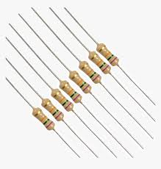

**FIG.2 RESISTOR**

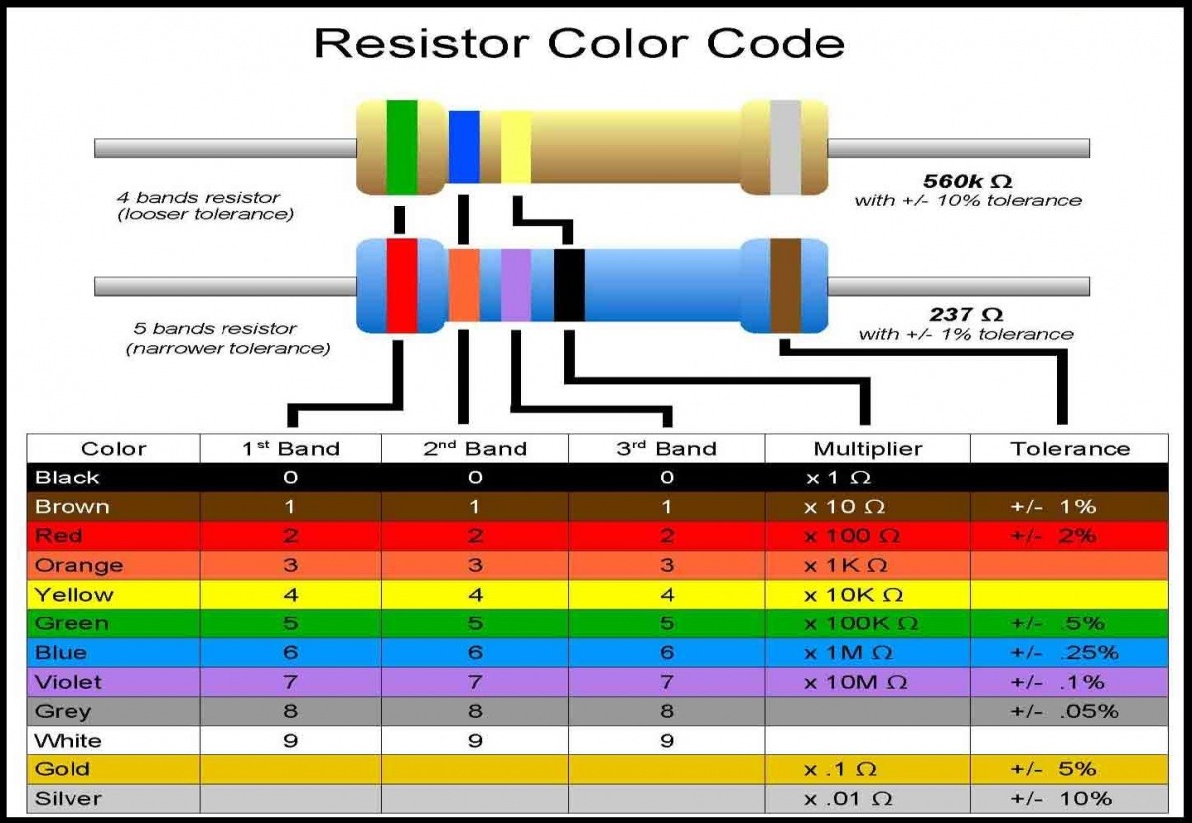 **FIG.3 RESISTOR COLOR CODE**

# 2.3 CAPACITORS

In practice **capacitors** are often classified according to the material used as the dielectric with the dielectrics divided into two broad categories: bulk insulators and metal-oxide films (so-called *electrolytic capacitors*).

## Capacitor construction

Capacitors have thin conducting plates (usually made of metal), separated by a layer of dielectric, then stacked or rolled to form a compact device.

### Fixed value capacitors

Many types of capacitor are available commercially, with capacitances ranging from the picofarad range to more than a farad, and voltage ratings up to many kilovolts. In general, the higher the capacitance and voltage rating, the larger the physical size of the capacitor and the higher the cost. Tolerances in capacitance value for discrete capacitors are usually specified as a percentage of the nominal value. Tolerances ranging from 50% (electrolytic types) to less than 1% are commonly available. Another figure of merit for capacitors is stability with respect to time and temperature, sometimes called *drift*. Variable capacitors are generally less stable than fixed types.

|  |  |  |
| --- | --- | --- |
| **Capacitor** | **Polarized capacitors** | **Variable capacitor** |
| [Capacitor symbol.png](https://static.wikia.nocookie.net/engineering/images/0/0a/Capacitor_symbol.png/revision/latest?cb=20060224044819) | [Polarized capacitor symbol.png](https://static.wikia.nocookie.net/engineering/images/f/f2/Polarized_capacitor_symbol.png/revision/latest?cb=20060224045134)  [Polarized capacitor symbol 2.png](https://static.wikia.nocookie.net/engineering/images/5/51/Polarized_capacitor_symbol_2.png/revision/latest?cb=20060224045750)  [Polarized capacitor symbol 3.png](https://static.wikia.nocookie.net/engineering/images/3/39/Polarized_capacitor_symbol_3.png/revision/latest?cb=20060224050109)  [Polarized capacitor symbol 4.png](https://static.wikia.nocookie.net/engineering/images/d/dd/Polarized_capacitor_symbol_4.png/revision/latest?cb=20060224050420) | [Variable capacitor symbol.png](https://static.wikia.nocookie.net/engineering/images/b/b2/Variable_capacitor_symbol.png/revision/latest?cb=20060224045439) |

#### Capacitors using bulk insulators

The electrodes need round edges to avoid field emission. Air has low breakdown voltage, so any air inside a capacitor - especially at the edges - will reduce the voltage rating. Even closed air bubbles in the insulator or between the insulator and the electrode lead to gas discharge in High Frequency applications.

* **Air-gap**: An air-gap capacitor has a low dielectric loss and offers good cooling. Large-valued tunable capacitors can be made this way. Good for resonating HF antennas.
* **Ceramic**: The main differences between ceramic dielectric types are the temperature coefficient of capacitance, and the dielectric loss. C0G and NP0 (negative-positive-zero, i.e. ±0) dielectrics have the lowest losses, and are used in filters, as timing elements, and for balancing crystal oscillators. Ceramic capacitors tend to have low inductance because of their small size. NP0 refers to the shape of the capacitor's temperature coefficient graph (how much the capacitance changes with temperature). NP0 means that the graph is flat and the device is not affected by temperature changes.
  + **C0G** or **NP0** — Typically 4.7 pF to 0.047 µF, 5%. High tolerance and temperature performance. Larger and more expensive.
  + **X7R** — Typical 3300 pF to 0.33 µF, 10%. Good for non-critical coupling, timing applications. Subject to microphonics.
  + **Z5U** or **2E6** — Typical 0.01 µF to 2.2 µF, 20%. Good for bypass, coupling applications. Low price and small size. Subject to microphonics.
  + **Ceramic chip**: 1% accurate, values up to about 1 µF, typically made from Lead zirconate titanate (PZT) ferroelectric ceramic
* **Glass** — used to form extremely stable, reliable capacitors.
* **Paper** — common in antique radio equipment, paper dielectric and aluminum foil layers rolled into a cylinder and sealed with wax. Low values up to a few μF, working voltage up to several hundred volts, oil-impregnated bathtub types to 5,000 V used for motor starting and high-voltage power supplies.
* **Polycarbonate** good for filters, low tempco, good aging, expensive
* **Polyester**, Mylar®: (from about 1 nF to 1 μF) signal capacitors, integrators.
* **Polystyrene**: (usually in the picofarad range) stable signal capacitors.
* **Polypropylene**: low-loss, high voltage, resistant to breakdown, signal capacitors.
* **PTFE** or Teflon ™: higher performing and more expensive than other plastic dielectrics.
* Silvered **mica**: These are fast and stable for HF and low VHF RF circuits, but expensive.

### 2.4 General Purpose PCB

#### Zero PCB or Dotted PCB also known as Perfboard are perfect for quick prototyping General Purpose PCB and can be used by students for school and college projects. These PCB's are also used by Hobbyist and in Industries for R&D and Testing of small circuits.

#### [Printed circuit Board](https://en.wikipedia.org/wiki/Printed_circuit_board) commonly abbreviated as PCB is the base(literally) of electronics. The PCB provides support as well as electrically connects various Electronic Components in the circuit.

#### For testing or for mounting your components you can either design and manufacture a custom PCB or else you can mount it on a zero PCB and accordingly make the connections. General Purpose PCB are perfect if you have not finalized the design or you are making the circuit just once like for a school or college project.

### Advantages of using General Purpose PCB

#### Low cost.

#### Perfect for Prototyping and testing small circuits.

#### Perfect for all who are starting with Electronics.

#### Short Design Time

#### You can change the circuit at any time

Disadvantages of using General Purpose PCB

#### Cannot be used for Mass Production.

#### Difficult to Repair or Troubleshoot.

#### Soldering skills required.

#### Difficult to use for complex circuits.

#### Customized PCB's take time and expertise to manufacture. You can also make custom PCB for your project for which you will require [Bare copper clad PCB](https://www.dnatechindia.com/PCB/Copper-Clad.html) and some other material as well. You can find online how to make custom PCB at home.

#### Normally three different types of general purpose PCB's are available in the market below we have given the list of dotted PCB's available in the market.

## Types of General Purpose PCB :

## Typical zero PCB

## FIG. 4 PCB

### Single Sided Paper Phenolic

#### This is made of FR1 or FR2 type of copper clad (Paper phenolic) and are mostly used by students and hobbyist as they are low cost and easily available. In this type you can mount the components on one side and solder from the other side of PCB. Copper is available only on one side of the PCB.

### Single Sided Glass Epoxy

#### This is made of FR4 type of copper clad (glass epoxy) used by students, hobbyist as well as in Industry these PCB are more sturdy as compared to Paper phenolic type. In this type you can mount the components on one side and solder from the other side of PCB. Copper is available only on one side of the PCB

### Double Sided Glass Epoxy

#### This is made of FR4 type of copper clad (glass epoxy) these are used by hobbyist and are mostly used in Industry. In this type you can mount the components on both side as well as you can solder from both sides of PCB. Copper is available on both side of the PCB. Moreover the holes can be PTH (Plated through Holes) or NPTH (Non Plated through Holes). Most of the double sided PCB are PTH types but some local manufacturers (in India) manufacture NPTH types types as well.

### Flexible PCB

#### These are new types of PCB not easily available in the market. These PCB's are flexible like a cloth and thus can be used where you can't use a Paper phenolic or glass epoxy PCB. These PCB are flexible thus you can easily adjust the circuit on it even in a small constraining place.

#### So if you are a newbie in the field or electronics or Electronic Hobbyist or a R&D Engineer you will be using a General purpose PCB.

#### DNA Solutions has various types and sizes of Zero or Dotted PCB as per your requirement. You can buy various types of [zero PCB for prototyping from our online Electronic Component store](https://www.dnatechindia.com/PCB/General_Purpose_PCB.html).

**2.5 BATTERY (12V):**

The nine-volt battery, or 12-volt battery, is a common size of battery that was introduced for the early transistor radios. It has a rectangular prism shape with rounded edges and a polarized snap connector at the top. This type is commonly used in walkie-talkies, clocks and smoke detectors. The nine-volt battery format is commonly available in primary carbon zinc and alkaline chemistry, in primary lithium iron disulfide, and in rechargeable form in nickel-cadmium, nickel-metal hydride and lithium ion. Mercury-oxide batteries of this format, once common, have not been manufactured in many years due to their mercury content. Designations for this format include NEDA 1604 and IEC 6F22 (for zinc-carbon) or MN1604 6LR61 (for alkaline). The size, regardless of chemistry, is commonly designated PP3—a designation originally reserved solely for carbon-zinc, or in some countries, E or E block. Most nine-volt alkaline batteries are constructed of six individual 1.5 V LR61 cells enclosed in a wrapper. These cells are slightly smaller than LR8D425 AAAA cells and can be used in their place for some devices, even though they are 3.5 mm shorter. Carbon-zinc types are made with six flat cells in a stack, enclosed in a moisture-resistant wrapper to prevent drying. Primary lithium types are made with three cells in series.

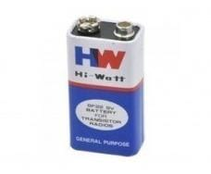

**FIG.5 BATTERY 12V**

**3. CIRCUIT DIAGRAM:**

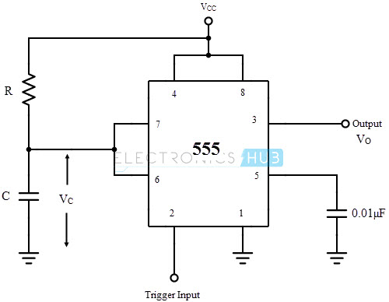

**FI**

**FIG.6 CIRCUIT DIAGRAM**

**4. Working Principle:**

* The Monostable Multivibrator will be in its stable state (Output LOW) until it is triggered.
* When a negative trigger is applied to the Trigger pin of 555 Timer, output of lower comparator will become HIGH and output of upper comparator will be LOW, since the capacitor voltage is zero. This makes the output HIGH.
* The Discharge transistor turns OFF and the capacitor starts charges through resistor R to Vcc.
* After the negative trigger, output of lower comparator becomes LOW and that of upper comparator remains LOW. Since both inputs of the SR Flip Flop are LOW, output will not change, so the output is HIGH
* When the capacitor voltage will become greater than 2/3 Vcc, output of upper comparator becomes HIGH and that of lower comparator remains LOW, so the output becomes LOW.
* This turns ON the discharge transistor and the capacitor discharges.
* The circuit remains in its stable state (Output LOW) until next trigger occurs.

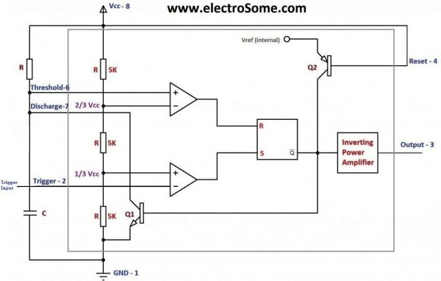

**FIG.7**

**5. OUTPUT WAVEFORM**

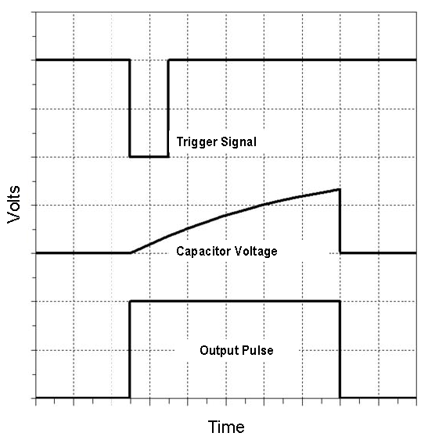

**FIG .8 OUTPUT WAVEFORM**

**6. SPECIFICATIONS:**

The general-purpose monostable multivibrator specifications are shown below

* This generator produces five types of waveforms
* The wide range of frequencies are generated by this generator
* For an analog generator, the frequency stability is 0.1 % per hour
* The maximum sine wave distortion for analog generators is about 1%
* The modulations AM (Amplitude Modulation), FM(Frequency Modulation) or PM (Phase Modulation) are supported
* The amplitude output is up to 10V

**7. APPLICATIONS:**

#### Hidden Active Cell Phone Detector using a 555 timer

This project is designed to detect any activated mobile phone from a distance of about one-and-a-half feet to avoid the use of un-authorized cell phone in prohibited areas. In this project, the active cell phone detector is designed with 555 timer IC and it is operated in monostable mode. If any person tries to make a call or send a message, then the buzzer will give an alarm in the presence of an active cell phone.

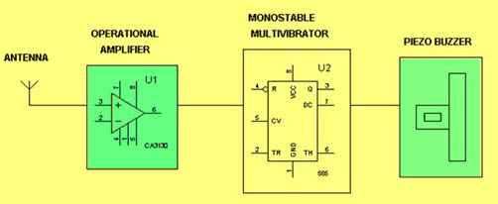

**FIG.9 Hidden Active Cell Phone Detector using a 555 timer**

#### 555 timer IC based Touch Controlled Load Switch

The main goal of this project is to control a load in a short-time duration by using a 555 timer and a touch plate. This 555 timer IC operates in a monostable mode, which is activated by a touch plate connected to its trigger pin. The o/p of the 555 timer sends a logic high for a particular time interval that is decided by the RC time constant. This o/p drives a relay to switch on the load in the fixed time duration and after it switches off automatically.

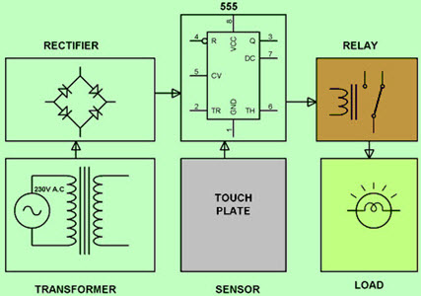

**FIG.10 555 Timer IC based Touch Controlled Load Switch Block Diagram**

**8. COST OF EQUIPMENT**

As it is one of the governing factors to do our project we tried to be cost efficient in the case of selection of equipment. The selected equipment that is indicated above is as much as possible less cost and easily affordable with a minimum cost. When we analyze the source of fund it is mainly depend on our individual contribution and the campus specifically the department. We planned that, if the materials are available in the campus we try to get from the campus if not we will bought the equipment from market.

**9. ADVANTAGE**

Monostable multivibrators generate output signals at timed intervals in the form of square waves. They are half the size of a stable multivibrators and can, therefore, be used in more diverse situations. Monostable multivibrators can be connected to one another to provide additional functionality. They are relatively simple in design and are inexpensive when compared with other types of oscillators**.**

**10. FUTURE SCOPE**

The main aim of the project is to save the power, by using effectively we can save more power, as we know that there is shortage of power nowadays in everywhere mostly in villages etc. So to overcome that we can provide street lights automatically with the centralized intelligent systems. So in future we can design many more advanced technologies to save power.

The future scope of this project can be implemented using LDR and Arduino, it can be further implemented as a system in which when the motion of the vehicle is detected then it will automatically turn on and vice versa.

**11.REFERENCE**

**www.wikipedia.com**

**www.slideshare.com**

**www.scribd.com**

**https://circuit.com**

[**https://circuitelectro.com**](https://circuitelectro.com)

[**https://www.embeddronics.com**](https://www.embeddronics.com)

**CERTIFICATE**

This is to certify that HARSHIT UPADHYAY and YASH TOMAR, students of ECE 3RD year have successfully completed the mini project on the topic: MONOSTABLE MULTIVIBRATOR under the guidance of MR.MAYANK RAI. This project is genuine and does not indulge in plagiarism of any kind. The references taken in making this project have been declared at the end of this report.

Signature